# 5 THE LAWS OF MOTION

## 5.2 Newton’s First Law and Inertial Frames

*If an object does not interact with other objects, it is possible to identify a reference frame in which the object has zero acceleration*

Any reference frame that moves with constant velocity relative to an inertial frame is itself an inertial frame

In the absence of external forces and when viewed from an inertial reference frame, an object at rest remains at rest and an object in motion continues in motion with a constant velocity (that is, with a constant speed in a straight line)

When no force acts on an object the acceleration of the object is zero. Any isolated object (no interaction with its environment) is either at rest and stays at rest, or is moving with constant velocity

**Inertia**: the tendency of an object to resist any attempt to change its velocity

## 5.3 Mass

**Mass**: property of an object that specifies how much resistance an object exhibit to changes in its velocity [kg]

The greater the mass of an object, the less that object accelerates under the action of a given applied force

## 5.4 Newton’s Second Law

When viewed from an inertial reference frame, the acceleration of an object is directly proportional to the net force acting on in and inversely proportional to its mass

Ftot = ma

## 5.6 Newton’s Third Law

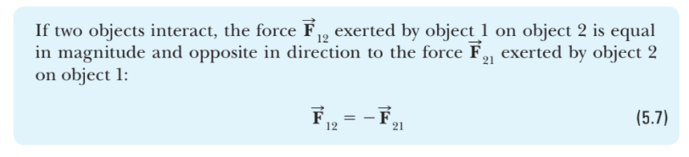

## 5.8 Forces of Friction

Magnitude of the force of kinetic friction acting between two surfaces is

fk = μkn

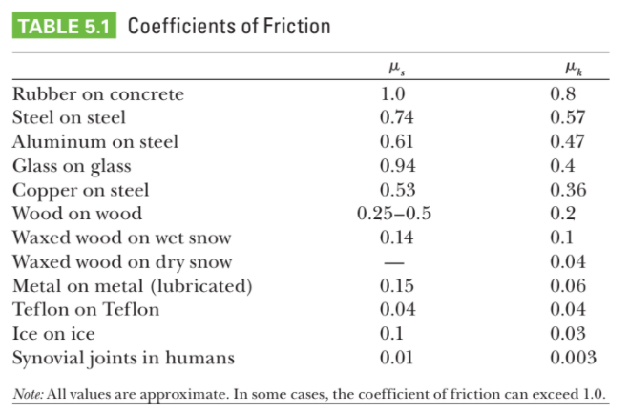

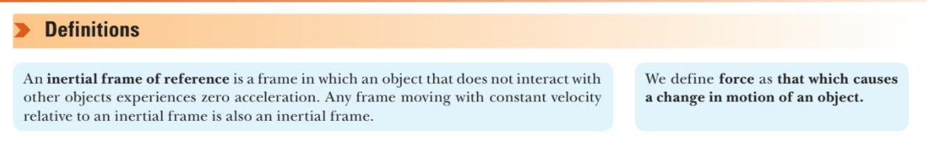

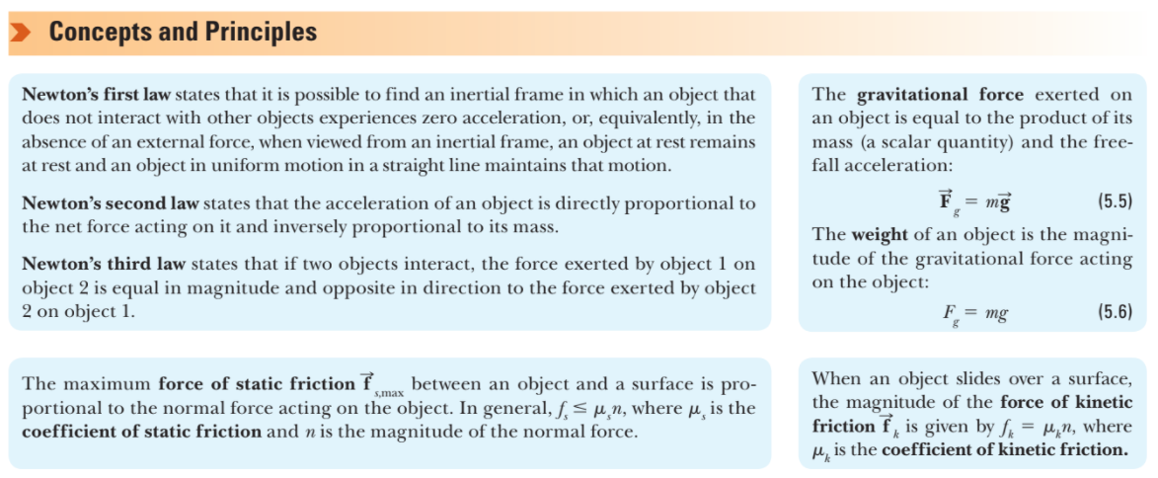

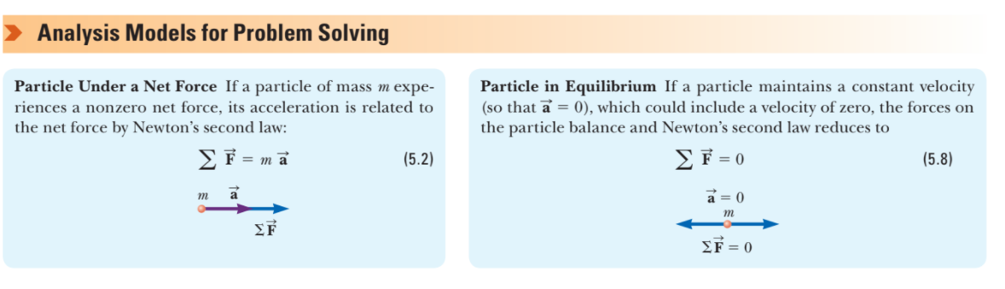

# 6 CIRCULAR MOTION AND OTHER APPLICATION OF NEWTON’S LAWS

**Centripetal acceleration**:

ac = v2 / r

It is directed toward the center of the circle. Always perpendicular to v

**Force causing centripetal acceleration**:

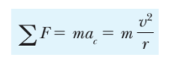

If the force should vanish the object would no longer move in a circular path

